How to change compiler command line in FBedit

1. Change Build Options
You can change the general build options via the menu items “Options” “Build Options”.
Attention: If you do use FBedit projects, note that each project uses its own build options. Use the menu items “Project” “Project Options” and then click the three dots “…” beneath “Build command”. If you do use modules, you can adjust the module build command separately in the project options.
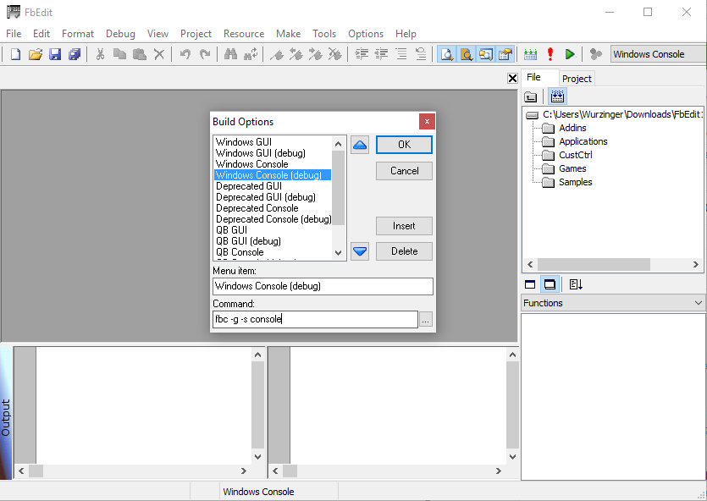
There you can verify the build options used for the different build variants.
You can also define your own build variant there. To do so, click “Insert” and enter a display name and the command to use. The command represents the build command as you would it call on the console without the source files (they will be appended). Do not use full paths for the compiler here as the set compiler path will be used, just use “fbc” for the compiler executable and specify the compiler options.
Here are some common compiler options (see http://freebasic.net/wiki/wikka.php?wakka=CompilerCmdLine for more):
-g include debug information in the compiled executable (needed for debugging)
-exx enable extended error checking
-s gui hide the console window (use for gui applications); console mode is the default
-lang select a freeBasic dialect: fb, qb or fblite
-dll build a dynamic library
-lib build a static library
-t sz set the stack size to “sz” bytes (insert a number)
-w all display all warnings
-v enable verbose compiler output
-x specify the path/name of the compiled executable

Example for a custom build variant:
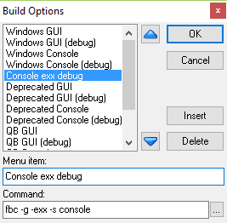

2. Ensure that your compiler path is set correctly
- Open Build Options via the menu items “Options” “Path Options”

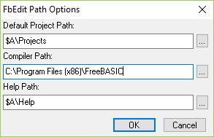

- The directory set in “Compiler Path” must contain “fbc.exe”

3. Select the build variant
Use the drop-down list on the right of the toolbar to select a build variant as defined/checked previously (in step 1). Verify the current build variant in the status bar. You can also see the full build command in the output window as soon as you build your code (press F5).
